COVID-19: analysis and visualization

COVID-19, a disease caused by SARS-CoV-2 corona virus, was first recognized in December 2019. It was ddeclared a pandemic by WHO in March 2020. The reported COVID-19 cases and deaths as at November 5, 2020 are as shown in the bar chats below; with the highest cases and deaths from America.

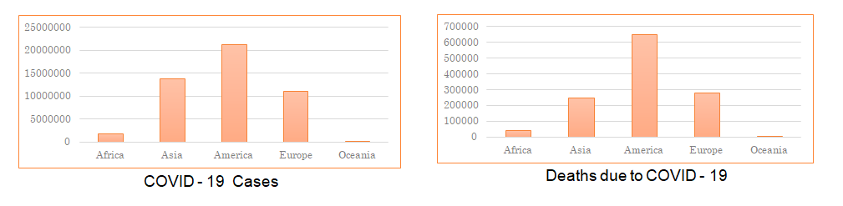
With the rise in the number of cases and mortality in some regions, we want to:
- Know what the trend is like in Canada.
- Know the economic impacts of COVID-19
  - Unemployment and GDP growth.
- Know the impacts of COVID-19 on excess deaths
- Know the relationship between COVID-19 deaths and deaths due to Influenza / Pneumonia.
Questions
- What is the wave of COVID-19 in Canada? (From February 2020 to September 2020).
- What is the impact of COVID-19 on unemployment in Canada?
- What is the impact of COVID-19 infections on excess deaths?
- Is there a trend between COVID-19 related deaths, and deaths due to seasonal flu (pneumonia and influenza) in the USA?
- What are the key patterns observed between interventions and economic impact? That is, COVID-19 vs. GDP growth for different countries?

Team Members and Roles
Pulling data - Nihal Joshua
Cleaning and transformation - Moné-Renata Holder
Analysis - Chris Inalsingh
Visualization - Bunmi Olakanmi
Report writing - Chris Inalsingh, Moné-Renata Holder
Presentation - Nihal Joshua, Bunmi Olakanmi

